**BWT Task-05 Exercise**

**Submitted By: Abduhu Khan**

**Q1**

**Write a query to calculate the percentage contribution of each item's amount to its order's total amount, grouped by order_id. (Topics: Partition BY)**

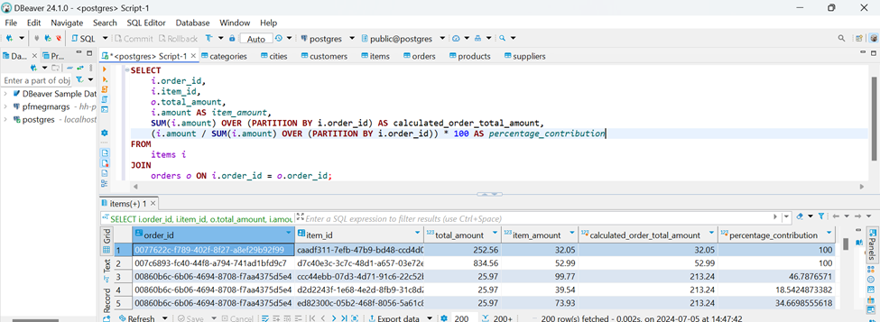

**SELECT**

*i*.order_id,

*i*.item_id,

*o*.total_amount,

*i*.amount **AS** *item_amount*,

**SUM**(*i*.amount) **OVER** (**PARTITION** **BY** i.order_id) **AS** calculated_order_total_amount,

(*i*.amount / **SUM**(*i*.amount) **OVER** (**PARTITION** **BY** i.order_id)) * 100 **AS** *percentage_contribution*

**FROM**

items *i*

**JOIN**

orders *o* **ON** *i*.order_id = *o*.order_id;

**Q2**

**Write a query to rank orders by their total amount within each customer, ordering them from highest to lowest total amount. (Topics: Window functions like RANK, PARTITION BY, and ORDER BY)**

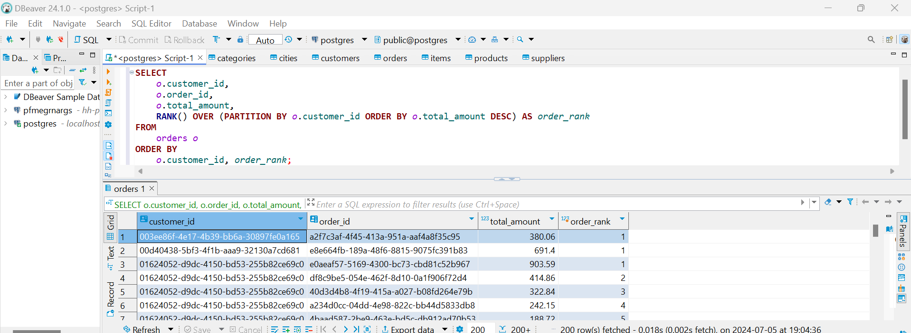

**SELECT**

*o*.customer_id,

*o*.order_id,

*o*.total_amount,

**RANK**() **OVER** (**PARTITION** **BY** *o*.customer_id **ORDER** **BY** *o*.total_amount **DESC**) **AS** *order_rank*

**FROM**

orders *o*

**ORDER** **BY**

*o*.customer_id, *order_rank*;

**Q3**

**Write a query to calculate the average price of products supplied by each supplier. Exclude suppliers who have no products in the result. (Topics: JOINS, AGGREGATE FUNCTIONS, GROUP BY)**

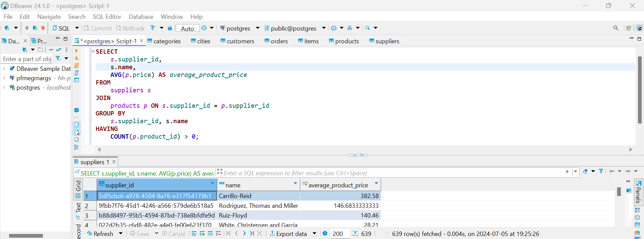

**SELECT**

*s*.supplier_id,

s.**name**,

**AVG**(*p*.price) **AS** *average_product_price*

**FROM**

suppliers *s*

**JOIN**

products *p* **ON** *s*.supplier_id = *p*.supplier_id

**GROUP** **BY**

*s*.supplier_id, s.**name**

**HAVING**

**COUNT**(*p*.product_id) > 0;

**Q4**

**Write a query to count the number of products in each category. Include categories with zero products in the result set. (WINDOW FUNCTIONS, AGGREGATE FUNCTIONS, JOINS, GROUP BY)**

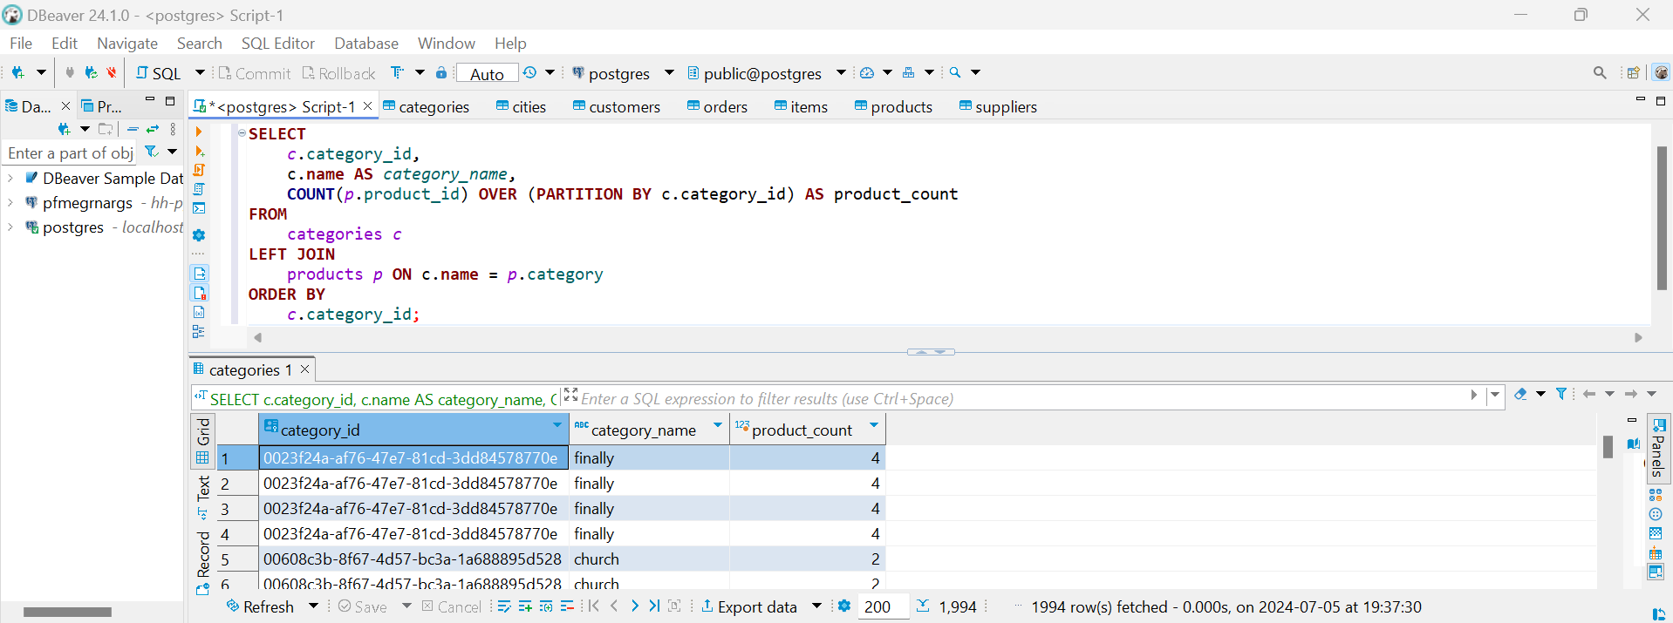

**SELECT**

*c*.category_id,

c.**name** **AS** *category_name*,

**COUNT**(*p*.product_id) **OVER** (**PARTITION** **BY** c.category_id) **AS** product_count

**FROM**

categories *c*

**LEFT** **JOIN**

products *p* **ON** c.**name** = *p*.category

**ORDER** **BY**

*c*.category_id;

**Q5**

**Write a query to retrieve the total amount spent by each customer, along with their name and phone number. Ensure customers with no orders also appear with a total amount of 0. (WINDOW FUNCTIONS, AGGREGATE FUNCTIONS, JOINS, GROUP BY)**

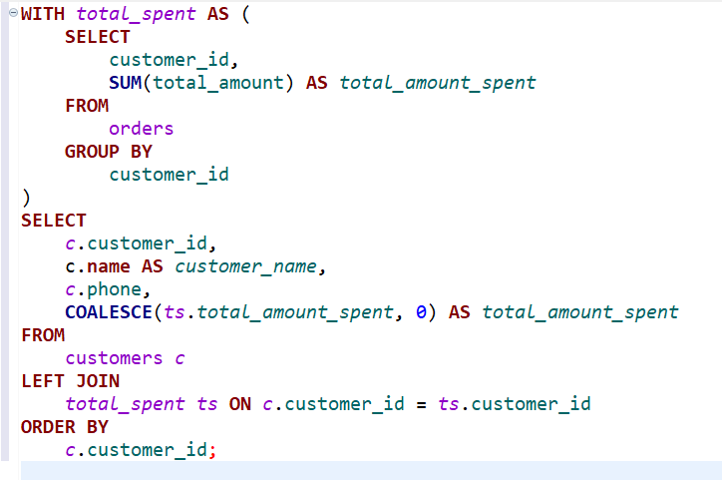

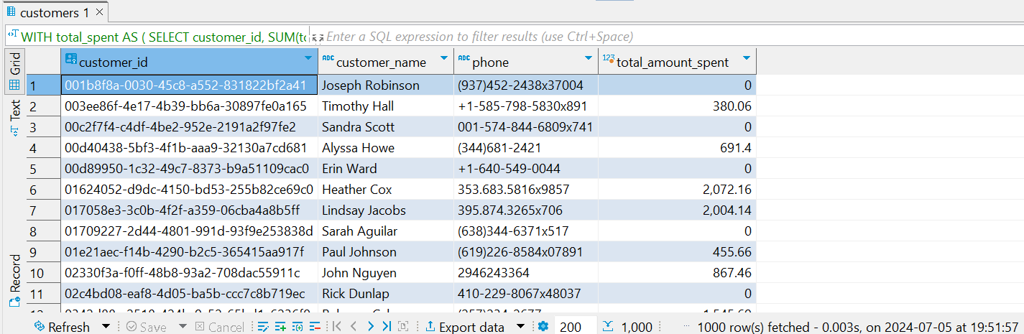

**WITH** *total_spent* **AS** (

**SELECT**

customer_id,

**SUM**(total_amount) **AS** *total_amount_spent*

**FROM**

orders

**GROUP** **BY**

customer_id

)

**SELECT**

*c*.customer_id,

c.**name** **AS** *customer_name*,

*c*.phone,

**COALESCE**(*ts*.*total_amount_spent*, 0) **AS** *total_amount_spent*

**FROM**

customers *c*

**LEFT** **JOIN**

*total_spent* *ts* **ON** *c*.customer_id = *ts*.customer_id

**ORDER** **BY**

*c*.customer_id;